**EXPERIMENT – 4**

OBJECTIVE:

Design an entity relationship diagram for the identified system.

INTRODUCTION:

The Entity relationship diagram explains the relationship among the entities present in the database. ER models are used to model real – world objects like a person like a person, a car or a company. In short ER diagram is a structural format of the database.

ER model is used to model the logical view of the system from a data perspective which consists if these symbols:

* Rectangle: Rectangles represent Entities in the ER model.
* Ellipses: they represent Attributes in the ER Model.
* Diamond: Diamonds represent the relationships among Entities.
* Lines: Lines represent attributes to entities and entity sets with other relationship types.
* Double Ellipse: Double Ellipses represent Multi – Valued Attributes.
* Double Rectangle: Double Rectangle represents a Weak Entity.

Entity relationship diagram for library management System:

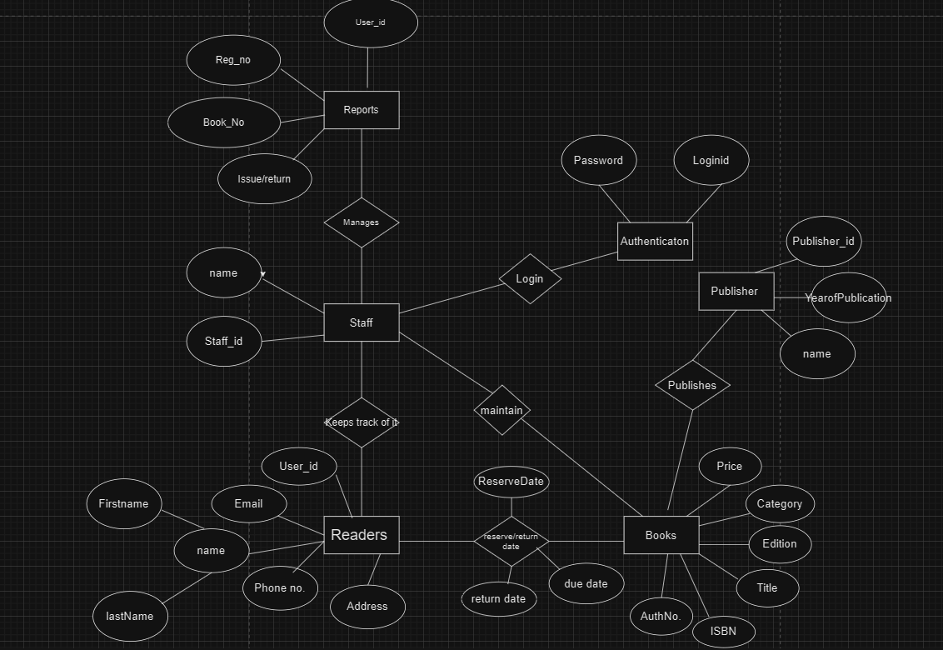

CONCLUSION :

In Summary , the entity relationship diagram is a method used in software engineering to produce a conceptual data model of an information system . Diagrams created using this ER – modelling method are called Entity Relationship Diagrams or ERD.

Document title (14)

Author (12)

Affiliation

Adress (college ka)

Date

Document version

Upar wale sabka alignment center me hoga

Introduction

Purpose of this document

Scope of this document

Overview

(Sab ka sab 12)

General description: user characteristics, importance, features, user community

Functional requirement

Interface Requirement

Performance Requirement

Design Constraints

Non functional attributes

Initial schedule and budget

Appendix (optional)

Conclusion